**REAL TIME CHAT APP**

Mind Map :

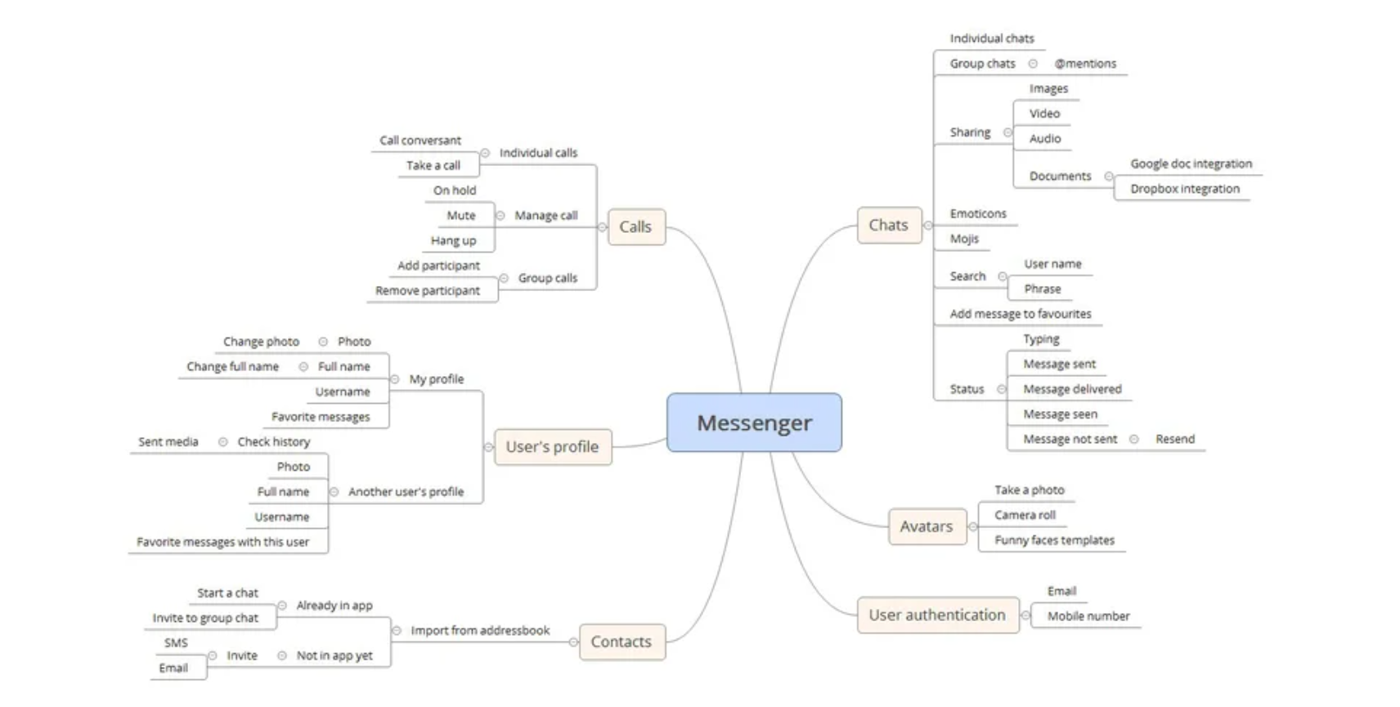

Functional Requirements :

* + - * + Registration
        + Adding contacts
        + Sending messages and media to individuals
        + Creating groups
        + Sending messages and media to groups
        + Viewing message history
        + Calling (audio and/or video)

Flow Diagram:

